Minutes of the General Meeting of the Comstock Grizzlies
Saturday August 16 3:00 PM
Dan and Tom’s Home

General information and attendance:

Meeting called to order @ 2:59 PM by Thomas

Meeting Attendee’s:
Dan, Tom, Thomas, Jason, Debby Hope, Max, Ron, Dean, Nick Terry (Nick’s Dad), Ben, and Kyle.

July 2025 minutes were sent to group.

Motion to approve as sent.
Motion: Tom Second Jason Approved by acclimation.

Current information for these minutes.
Treasurers Report: Through 08/16/2025

Previous Balance: $ 635.46
Transactions: IN $ 0.00
Ending Balance: $ 635.46
Net Change: $ 0

Motion to approve the Treasury Report.
Motion: Tom Second Thomas Approved by acclimation.

Although dues are not required to attend activities.
We are all encouraged to renew your dues
and look at friends to become members.
Just so we have funds for our club expenses.

Web/Facebook Report:
FULLY UPDATED

Old Business:

Summer outings continued

New Business:

Thomas mentioned the variety show from the Episcopal Church on September 28th. Check with Tim for more information.

Next Dinner Night Out (DNO)

No agreement reached.

Pot Luck Dinner and Club Meeting – Typically the 3rd
Saturday of the month

Next Meetings:
We are also planning ahead for the next 2 meetings.
August, September 2025

September Meeting and Pot Luck
Nathan and Ken’s Home Sparks
Saturday September 20th @ 6:30pm

No theme for this dinner.

Hope to see you all there.

Close the meeting:
Motion: Kyle, second Tom, Approved by acclimation.
Approved at 3:06 PM.

Respectfully Submitted
Dan J., substitute secretary August 21, 2025.

JULY

MAGIC CARPET MINI GOLF

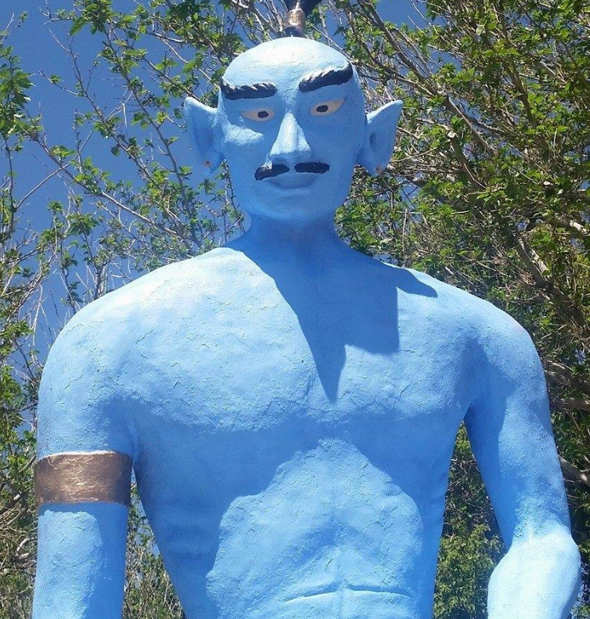
6925 S. VIRGINIA ST. RENO, NV 89511
COST $13 Cash $13.52 Card.
Planned for Wed July 23 @ 6:30pm

AUGUST

TRIP TO NEVADA MUSEUM OF ART

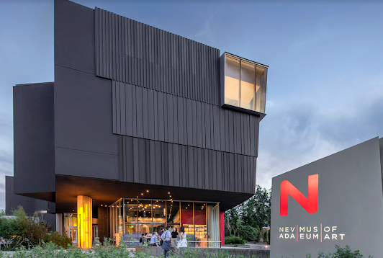

This outing would need to be on a Thursday and start earlier (5pm) do to their hours. Cost $15
I have asked Thomas to host this outing. Members will need to get with him to coordinate and confirm you are attending.
I have planned it for Thu Aug 14 @ 5pm due to their hours

TRIP TO RENO ANIMAL ARK

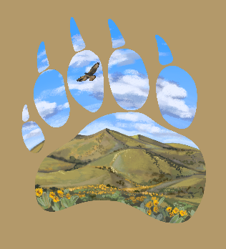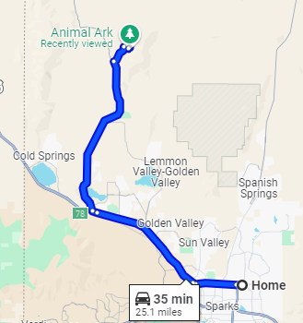
1265 Deerlodge Road. Reno, NV

This should be planned for a Saturday or Sunday.
Morning is best for viewing animals. Cost $20 / $16 Seniors.
Tickets only available online.
It is a 35 minute drive for our house so carpooling is suggested.
This will planned for Sunday Aug 24 @ 10:30am. Planning early start so it is not to hot and it is best time to see animals.

